CPE301 – SPRING 2019

Design Assignment 2B

Student Name: Rocky Yasuaki Gonzalez

Student #: 5003229733

Student Email: gonzar14@unlv.nevada.edu

Primary Github address: https://github.com/rockyg1995/ihswppdar.git

Directory: C:\Users\rocky\Documents\CpE 301+L - Embedded Systems Design\CpE

301\Repository\DesignAssignments\DA2B

Submit the following for all Labs:

1. In the document, for each task submit the modified or included code (only) with highlights and justifications of the modifications. Also, include the comments.
2. Use the previously create a Github repository with a random name (no CPE/301, Lastname, Firstname). Place all labs under the root folder ESD301/DA, sub-folder named LABXX, with one document and one video link file for each lab, place modified asm/c files named as LabXX-TYY.asm/c.
3. If multiple asm/c files or other libraries are used, create a folder LabXX-TYY and place these files inside the folder.
4. The folder should have a) Word document (see template), b) source code file(s) and other include files, c) text file with youtube video links (see template).

1. **COMPONENTS LIST AND CONNECTION BLOCK DIAGRAM w/ PINS**

Multifunction Shield

Atmega328PB Xplained Mini

Wire Connector

Micro USB Cable (Power Supply)

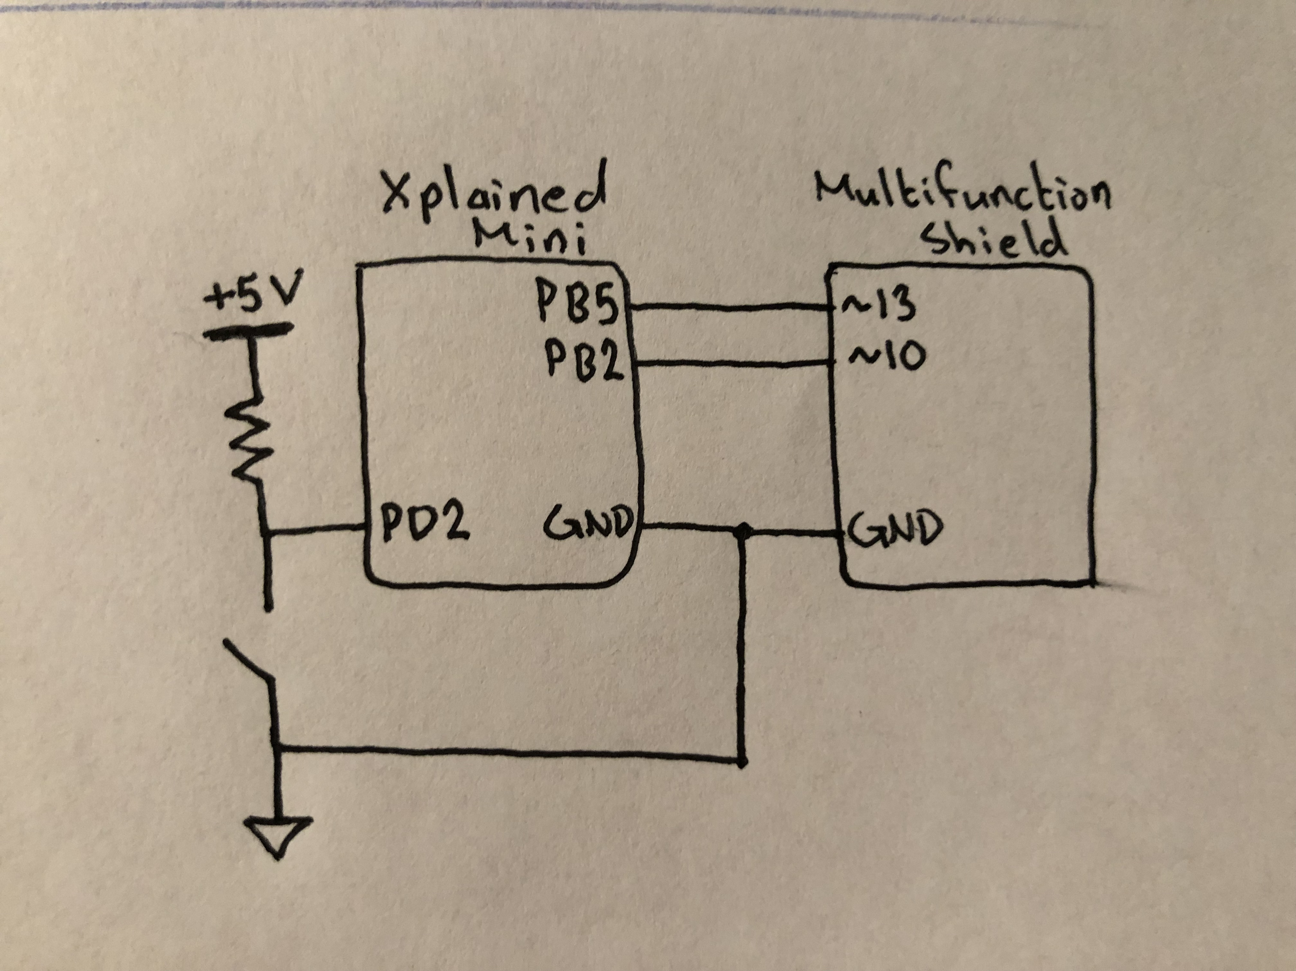

*Figure 1 – Block Diagram/Pin Connections*

1. **INITIAL/DEVELOPED CODE OF TASK 1/A**

; DA2B - Rocky Gonzalez.asm

;

; Created: 3/9/2019 8:39:31 AM

; Author: rocky

.ORG 0 ; Location for reset

JMP Main ; Label Address for Main

.ORG 0x02 ; Location for external interrupt 0

JMP EX0_ISR ; Label Address for External Interrupt 0

Main:

; Interrupt Related Initialization

LDI R20, HIGH(RAMEND) ; Load Upper RAM end address

OUT SPH, R20 ; Initialize Upper Stack Pointer

LDI R20, LOW(RAMEND) ; Load Lower Ram end address

OUT SPL, R20 ; Initialize Lower Stack Pointer

LDI R20, 0x2 ; Make 'INT0' falling edge triggered

STS EICRA, R20 ; External Interrupt Control Register A 'xxxx 0010'

SBI PORTD, 2 ; Activate pull-up in 'Interrupt 0' (PD2)

SBI DDRB, 5 ; Set PB5 as an Output (Interrupt LED)

CBI PORTB, 5 ; Set PB2 as 'High'

LDI R20, (1<<INT0) ; Enable 'INT0'

OUT EIMSK, R20 ; Store into 'EIMSK'

SEI ; Enable Global Interrupts

; Main Function Initialization

SBI DDRB, 2 ; Set PB2 as an Output

SBI PORTB, 2 ; Set PB2 as 'High'

Repeat:

CAll delay435ms ; Subroutine to Delay program 435ms

CBI PORTB, 2 ; Toggle LED 'Low' at PORTB.2

CAll delay290ms ; Subroutine to Delay program 290ms

SBI PORTB, 2 ; Toggle LED 'High' at PORTB.2

RJMP Repeat ; Repeat LED Squarewave Period (725ms)

delay435ms: ; Delay Program '290ms'

Push R16 ; Store R16 into Stack

Push R17 ; Store R17 into Stack

Push R18 ; Store R18 into Stack

LDI R18, 15 ;

L3: LDI R17, 200 ; 15

L2: LDI R16, 232 ; 200*15

L1: NOP ; 232*200*15

NOP ; 232*200*15

NOP ; 232*200*15

NOP ; 232*200*15

NOP ; 232*200*15

NOP ; 232*200*15

NOP ; 232*200*15

NOP ; 232*200*15

DEC R16 ; 232*200*15

BRNE L1 ; 232*200*15

DEC R17 ; 200*15

BRNE L2 ; 200*15

DEC R18 ; 15

BRNE L3 ; 15

Pop R18 ; Restore R18 from Stack

Pop R17 ; Restore R17 from Stack

Pop R16 ; Restore R16 from Stack

RET ; Complete Subroutine

delay290ms: ; Delay Program '290ms'

Push R16 ; Store R16 into Stack

Push R17 ; Store R17 into Stack

Push R18 ; Store R18 into Stack

LDI R18, 10 ;

M3: LDI R17, 200 ; 10

M2: LDI R16, 232 ; 200*10

M1: NOP ; 232*200*10

NOP ; 232*200*10

NOP ; 232*200*10

NOP ; 232*200*10

NOP ; 232*200*10

NOP ; 232*200*10

NOP ; 232*200*10

NOP ; 232*200*10

DEC R16 ; 232*200*10

BRNE M1 ; 232*200*10

DEC R17 ; 200*10

BRNE M2 ; 200*10

DEC R18 ; 10

BRNE M3 ; 10

Pop R18 ; Else, Restore R18 from Stack

Pop R17 ; Restore R17 from Stack

Pop R16 ; Restore R16 from Stack

RET ; Complete Subroutine

delay1s: ; Delay Program '290ms'

Push R16 ; Store R16 into Stack

Push R17 ; Store R17 into Stack

Push R18 ; Store R18 into Stack

LDI R18, 32 ;

N3: LDI R17, 200 ; 32

N2: LDI R16, 250 ; 200*32

N1: NOP ; 250*200*32

NOP ; 250*200*32

NOP ; 250*200*32

NOP ; 250*200*32

NOP ; 250*200*32

NOP ; 250*200*32

NOP ; 250*200*32

NOP ; 250*200*32

DEC R16 ; 250*200*32

BRNE N1 ; 250*200*32

DEC R17 ; 200*32

BRNE N2 ; 200*32

DEC R18 ; 32

BRNE N3 ; 32

Pop R18 ; Restore R18 from Stack

Pop R17 ; Restore R17 from Stack

Pop R16 ; Restore R16 from Stack

RET ; Complete Subroutine

EX0_ISR:

IN R21, PORTB ; ; Read in Value of PB5 to R21

LDI R22, (1<<5) ; '0010 0000' for toggling PB5

EOR R21, R22 ; XOR Current Status of Interrupt LED

OUT PORTB, R21 ; Output Interrupt LED

CAll delay1s ; Subroutine to Delay program 1000ms

RETI ; Return to Original Placement in Code

1. **INITIAL/DEVELOPED CODE OF TASK 2/A**

/*

* DA2B - C.c

*

* Created: 3/9/2019 11:04:58 AM

* Author: rocky

*/

#define *F_CPU* 16000000 // Slow Rate of delay from 1MHz to 8MHz

#include <avr/io.h> // Standard AVR Library

#include <avr/interrupt.h> // AVR library containing interrupt functions

#include <util/delay.h> // AVR library containing _delay_ms() function

#define LED 0b00000100 // Modify LED Bit here (Currently PB2)

#define ILED 0b00100000 // Modify Interrupt LED Bit here (Currently PB5)

int main(void) { // Main Function

DDRB = LED | ILED; // Set LED (PB2) and ILED (PB5) as an Output

PORTD |= 1<<2; // Activate Pull-up in PD2

PORTB |= LED; // Set LED as 'High'

PORTB &= ~ILED; // Set ILED as 'Low'

EICRA = 0x2; // Set as Falling Edge Trigger

EIMSK = (1<<INT0); // Enable External Interrupt 0

sei(); // Enable Global Interrupts

while (1) { // Loop LED Toggle, Period of 735ms (60% High, 40% Low)

*_delay_ms*(435); // Delay Program by 435ms (Multiply '16' because 16MHz)

PORTB &= ~LED; // Turn OFF LED (High-to-Low)

*_delay_ms*(290); // Delay Program by 290ms (Multiply '16' because 16MHz)

PORTB |= LED; // Turn ON LED (Low-to-High)

}

}

ISR (INT0_vect) { // External Interrupt 0

PORTB ^= (1<<5); // Toggle PB5 LED ON and OFF

*_delay_ms*(1000); // Toggle every 1000ms

}

1. **SCHEMATICS**

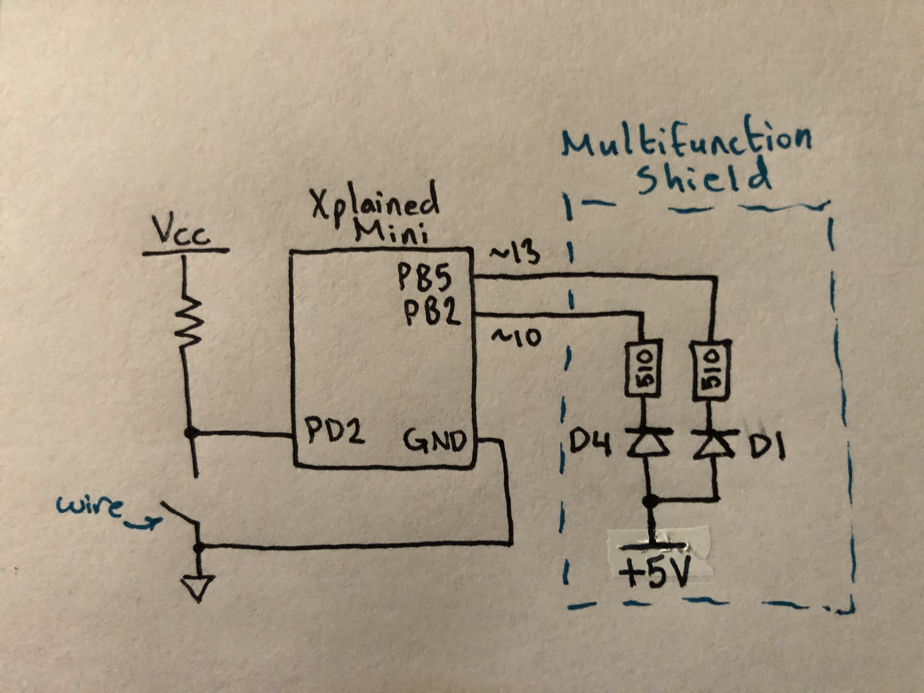

*Figure 2 – Schematic Connections for including External Interrupt*

1. **SCREENSHOTS OF EACH TASK OUTPUT (ATMEL STUDIO OUTPUT)**

Using a Logic Analyzer, we are able to observe that the C coding has a better response since the timer is more accurate that the Assembly Loop made. The following waveforms are the demonstrated C and Assembly code from Task 1 in DA2A except with an external interrupt now included:

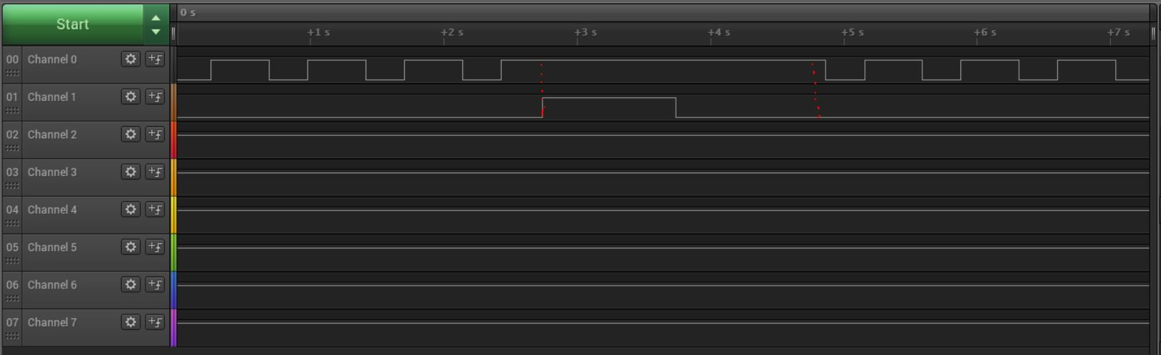

*Figure 3a – Output Waveform of Task 2.A1/DA2A (Assembly Coding)*

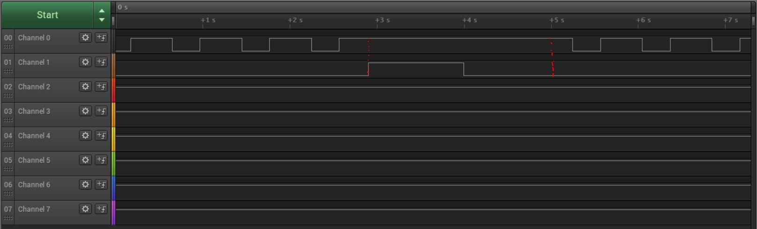

*Figure 3b – Output Waveform of Task 2A.1/DA2B (C Coding)*

1. **SCREENSHOT OF EACH DEMO (BOARD SETUP)**

Each Demo utilizes the same set up which includes a Shield Attachment placed on top of the Xplained Mini PB and a red wire connector from PD2 ready to connect to Ground. This set up is shown in *Figure 2*:

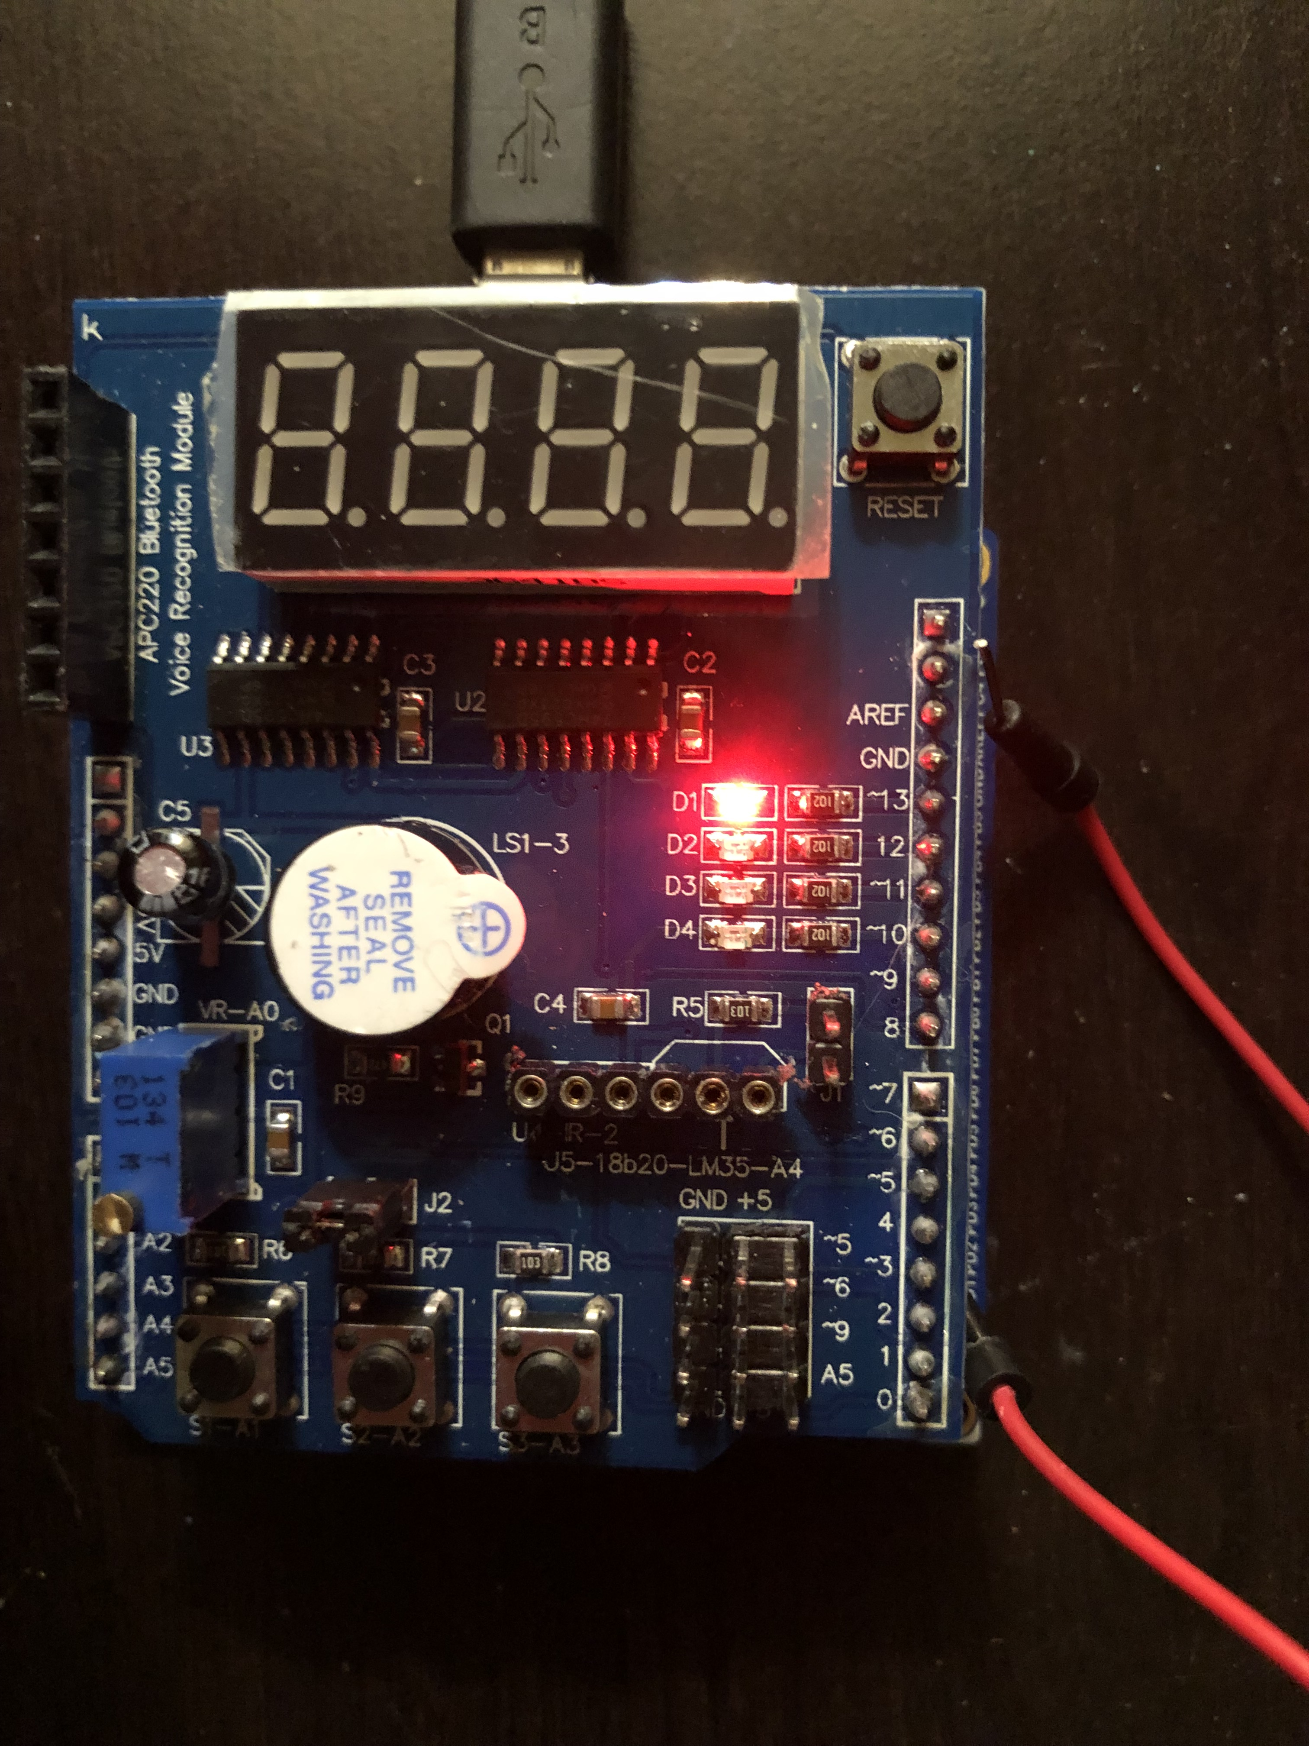

*Figure 4 – Wire attached from PD2 (Xplained Mini Board)*

1. **VIDEO LINKS OF EACH DEMO**

https://www.youtube.com/watch?v=gcYfJsiCccI

1. **GITHUB LINK OF THIS DA**

https://github.com/rockyg1995/ihswppdar/tree/master/DesignAssignments/DA2B

**Student Academic Misconduct Policy**

<http://studentconduct.unlv.edu/misconduct/policy.html>

“This assignment submission is my own, original work”.

Rocky Gonzalez